**Transform Your Retail Store with gridwall panels**

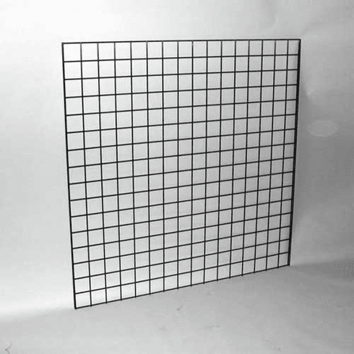

Many stores use **gridwall panels**, but consumers often overlook these useful display racks. Grid panels can be used in various ways to highlight the products in fresh and exciting ways; all it takes is a little imagination.

Gridwall panels and accessories are among the most cost-effective retail display systems available. Discount shops, department stores, pop-ups, seasonal stores, kiosks, trade show displays, and even flea markets use Gridwall and Slatgrid. Grid is an incredibly effective and cost-effective way to view merchandise when mounted on the wall or as freestanding displays. Consider using it for promotional pieces, endcaps, or permanent displays in your shop. **[Gridwall panels](https://www.americanretailsupply.com/gridwall-slatgrid.html)** are thin and light, but they're tough as nails. They are simple to set up and take down and they store products in a flat way to save backroom space.

**Gridwall is a fast, versatile, and low-cost solution.**

Gridwall is a popular option for new retailers because it is inexpensive, easy to find, and can be reconfigured in the future to suit various configurations. Gridwall is highly adaptable. Individual panels can be wall-mounted or zip-tied together to make free-standing devices. Gridwall is also lightweight and compact, making it a good option for free-standing displays at pop-up shops. Gridwall's drawbacks are mostly aesthetic. Gridwall can be difficult to make appear like a permanent fixture in your retail space, but it's not impossible.

Gridwall is a type of wall covering that is made up of metallic grids. It is typically mounted directly on the wall. The grid is dotted with hooks that allow store owners to show their wares. After the gridwall is firmly fastened to the wall, the store owner can hang hooks and load the gridwall with the merchandise. It's a relatively basic fixture that can be used in a variety of retail settings.

**Gridwall has a range of advantages.**

* It has a modern/contemporary appearance.
* Shipping is inexpensive.
* Installation is fast and easy.
* Most goods can be supported.
* Minimal upkeep is required.
* It can be mounted directly on the wall or used as a free-standing light fixture.

A lattice of wire panels forms the basis of this type of merchandising display, which can easily accommodate a range of hook and shelf options connected to the grid.

Grid Walls have many of the same advantages as slat walls. They, too, are adaptable, cost-effective, and customizable. On the other hand, Grid walls are much lighter and easier to maintain, requiring only minor dusting and cleaning.

With today's high rent rates, retailers are searching for cost-effective and versatile ways to use the wall and floor space, which is why the Grid Wall is ideal for traders looking to save space.

Grid wall fixtures are beneficial to clothing stores because hooks and hangers are simple to remove and relocate, allowing for a rapid merchandising upgrade with minimal effort. Impulse merchandising displays containing loose products such as confectionery, books, and magazines can also benefit from this form of display, as bins, baskets, and shelving are also easily attachable.

* **Color-matching**

[Grid wall panels](https://www.ehow.com/info_8473702_advantages-grid-connected-photovoltaic-systems.html) are available in 3 colors black, white, or chrome, often used by retailers to group similar products together. For example, one rack will be devoted entirely to hanging jeans, while another will house all of the available jewelry for purchase. You can spice up this standard concept by color-coordinating the pieces on the shelves. Hang all of your blue blouses, t-shirts, coats, and pants on one grid panel using hangers. Put identical hues on adjacent display racks to create a spectrum effect.

* **Get your outfits exclusive.**

Consider making clothes that your customers will like to wear while stocking your grid panel displays; instead of hanging clothing pieces that only contain one object, pair items that go well together and could be purchased as a package. Put a mannequin nearby dressed in all of the things on the show to emphasize the point.

* **Complement with display tables.**

By matching hanging objects with those on display tables nearby, you may draw your grid panels' attention. Using a display table to show off watches, sunglasses, purses, or shoes would go well with the outfit if you have a few cute skirts or dresses hanging on the wall. If you're going for the above-mentioned color scheme, you can match the hue on the wall display to stackable objects on your tables. To take this concept even further, use wholesale ribbon as a decoration.

**Shelving and hanging equipment are kept apart.**

While having a mix of shelves, baskets, and hangers-on each panel can seem to be a good idea, this strategy may reduce the display's storage efficiency and overall aesthetic appeal. The easiest way to remain organized is to keep your gridwall accessories apart.

Hanging accessories, for example, should be mounted on just one wall, one on top of the other, or side by side if space allows. Shelves would typically cover two gridwall panels, but that does not mean they cannot be arranged. Shelves, for example, can be mounted on the top half of the unit, while baskets can be installed on the bottom half.